2023
Year 12 Integrated Science – Unit 4
Task 7: Chemical Reactions Test
Weighting: 5%
Duration: 45 minutes

Name: _______________________

Date: _________________
Multi-choice | $${}/{10}$$
Short Answer | $${}/{16}$$
Extended Answer | $${}/{13}$$
Total Mark | $${}/{39}$$

I acknowledge that all the information contained in this task is my own work and not taken from other sources. If other sources have been used, they have been acknowledged in my references.

____________________________________
(Student Signature)

Please see SEQTA for teacher feedback and comments.
MULTI-CHOICE SECTION:
Please answer the below questions by circling the correct answer. (10 marks)

- Which of the following is an example of a physical change?
- A gas being produced when a metal is added to an acid
- Salt crystals dissolving in water
- A solid forming when two solutions are added together
- A temperature increase when a metal is added to water

- During an acid-metal reaction, the products formed from this reaction are:
- Carbon Dioxide and Water
- Metal Salt and Carbon Dioxide
- Metal Salt and Hydrogen Gas
- Carbon Dioxide and Hydrogen Gas

- Which of the following are products of a complete combustion reaction?
- Carbon Dioxide and Carbon Monoxide
- Carbon Dioxide and Water
- Water and Carbon Monoxide
- Oxygen and Carbon Dioxide

- What is the correct formula for Ethane?
- CH₄
- C₁₈H₂₄
- NH₄H
- C₂H₆

- Which is NOT a sign of a chemical change?
- Gas production
- Heat production
- Dissolving
- Colour change

- Steel is used in cars for its corrosion resistance, what is the name of this material?
- Metal
- Composite
- Iron
- Alloy

- Which of the following is not a common property of metals?
- Malleable
- Dull
- Ductile
- Good conductor of heat

- Which of the following is the balanced chemical reaction for the combustion of Methane?
  - CH₄ + O₂ → CO₂ + H₂O
  - 3C₄H_{10.} + 11O_{2.} 12CO₂ + 9H₂O
  - CH₄ + 2O₂ → CO₂ + 2H₂O
  - 3CH₄ + 2O₂ → 3CO₂ + 6H₂O

- Identify which of the below would produce hydrogen gas when reacted with hydrochloric acid (HCl)
  - Aluminium (Al)
  - Calcium carbonate (CaCO₃)
  - Ammonium (NH₄)
  - Oxygen (O₂)

- Hydrocarbons are:
  - Compounds that only contains carbon bonded to itself
  - Compounds that only contain carbon and hydrogen
  - Compounds that do not contain carbon
  - Compounds that contain carbon and other elements

SHORT ANSWER SECTION:

- Identify and explain one example of a physical change. (2 marks)
____________________________________________________________________________________________________________________________________________________________________________________________________________________________________

- Provide three indicators for a chemical change (3 marks)
- _______________________________
- _______________________________
- _______________________________

- 2.5g of a white powder was in a crucible. It was heated with a Bunsen burner until a liquid formed. After cooling a piece of white solid remained. It weighed 2.0g. Explain whether this is a physical or chemical change. Give a reason for your answer. (4 marks)

____________________________________________________________________________________________________________________________________________________________________________________________________________________________________________________________________________________________________________________________________________________________________________________________

- For questions a) below, provide the word equation and balanced formula equation, and identify the type of reaction for each.

  - Zinc (Zn) and hydrochloric acid (HCl) react to form zinc chloride (ZnCl₂) and hydrogen gas (H₂) (3 marks)

Word Equation:

Formula Equation:

Type of reaction: _____________________________________________________________
For part b) below, supply the missing chemicals, identify the type of reaction and write down the generic equation for each type of reaction. (4 marks)

Magnesium carbonate + sulfuric acid → ___________________ + __________________ + water

Type of reaction: ___________________________________________________________

Generic reaction equation:

EXTENDED ANSWER SECTION:
Answer the below questions based on the data provided.

Title: Clean Cities Energy Use Impact by Fuel Type (million GGEs)

 | 2004 | 2005 | 2006 | 2007 | 2008 | 2009 | 2010 | 2011 | 2012 | 2013 | 2014 | 2015 | 2016 | 2017 | 2018
CNG | 89 | 56 | 81 | 102 | 104 | 85 | 141 | 167 | 191 | 231 | 293 | 402 | 430 | 426 | 411
Biodiesel | 21 | 47 | 63 | 61 | 74 | 39 | 29 | 70 | 59 | 61 | 59 | 78 | 102 | 94 | 116
E85 | 16 | 26 | 45 | 37 | 37 | 73 | 39 | 49 | 38 | 48 | 51 | 68 | 71 | 86 | 71
LNG | 0 | 8 | 16 | 9 | 14 | 12 | 23 | 28 | 21 | 22 | 34 | 53 | 45 | 47 | 52
Propane | 39 | 32 | 42 | 30 | 25 | 18 | 18 | 19 | 27 | 27 | 32 | 37 | 45 | 44 | 52
Electric | 3 | 2 | 5 | 5 | 4 | 29 | 9 | 16 | 12 | 20 | 27 | 33 | 41 | 26 | 45
Acronyms:
CNG: Compressed natural gas
E85: 85% ethanol, 15% gasoline
LNG: Liquefied natural gas
GGEs= gasoline gallon equivalents

- Provide the missing labels in the table above. (2 marks)

- Identify the following variables from the above table (2 marks)

Independent Variable: ______________________________________________________

Dependent Variable: ______________________________________________________

- Provide one controlled variable that must have been followed for the data to be collected AND explain why it needs to be controlled. (2 marks)

____________________________________________________________________________________________________________________________________________________________________________________________________________________________________________________________________________________________________________

- Create an appropriate graph to represent the Electric and Biodiesel data from the above table. (5 marks)

- Using the graph above, describe the trends observed and provide an explanation for the results. (2 marks)

____________________________________________________________________________________________________________________________________________________________________________________________________________________________________________________________________________________________________________

END OF ASSESSMENT

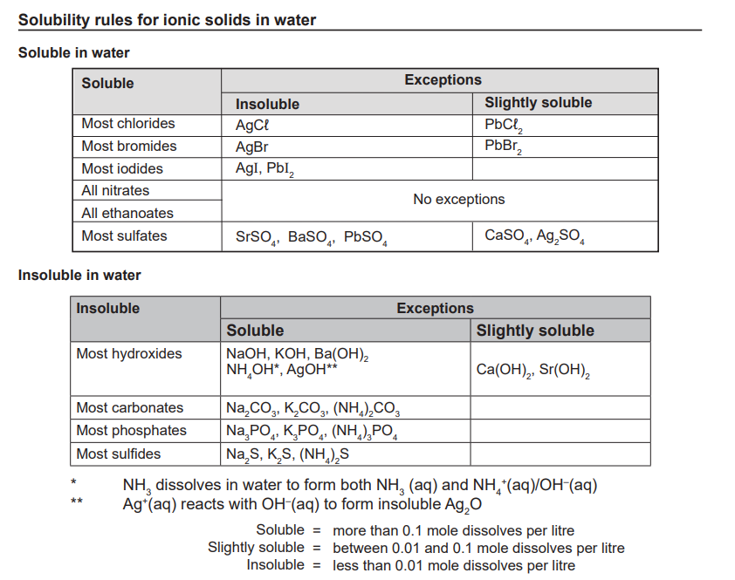

Ion Valency Table
Positive Ions |  | Negative Ions
Name | Symbol | Name | Symbol
Hydrogen | H⁺ | Fluoride | F⁻
Sodium | Na⁺ | Chloride | Cl⁻
Potassium | K⁺ | Bromide | Br⁻
Silver | Ag⁺ | Iodide | I⁻
Lithium | Li⁺ | Hydrogen carbonate | HCO₃⁻
Copper (I) | Cu⁺ | Hydrogen sulfate | HSO₄⁻
Ammonium | NH₄⁺ | Hydroxide | OH⁻
Magnesium | Mg²⁺ | Ethanoate | CH₃COO⁻
Calcium | Ca²⁺ | Nitrate | NO₃⁻
Barium | Ba²⁺ | Oxide | O²⁻
Iron (II) | Fe²⁺ | Sulfide | S²⁻
Cobalt | Co²⁺ | Sulfate | SO₄²⁻
Zinc | Zn²⁺ | Sulfite | SO₃²⁻
Lead (II) | Pb²⁺ | Carbonate | CO₃²⁻
Tin (II) | Sn²⁺ | Nitride | N³⁻
Copper (II) | Cu²⁺ | Phosphide | P³⁻
Aluminum | Al³⁺ | Phosphate | PO₄³⁻
Chromium (III) | Cr³⁺
Iron (III) | Iron³⁺
Tin (IV) | Sn⁴⁺
Lead (IV) | Pb⁴⁺
